Workgroup C1.067

Charter report

17/02/2025

Aarón Jesús Acuña Bellido - [aaracubel@alum.us.es](mailto:aaracubel@alum.us.es)

Javier Arellano López – [javarelop@alum.us.es](mailto:javarelop@alum.us.es)

Raúl Calero Capote – [raucalcap@alum.us.es](mailto:raucalcap@alum.us.es)

Tudor Cristian Lacatus Cosma [-ionlac@alum.us.es](mailto:-ionlac@alum.us.es)

Miguel Prado Jiménez – [migprajim@alum.us.es](mailto:migprajim@alum.us.es)

Table of Contents

INTRODUCTION 4

RECRUITING PROCESS 4

CONTACT INFORMATION 4

COMMITMENT STATEMENT 5

PERFORMANCE INDICATORS 6

Assistance to Lectures 6

Assistance to Team Meetings 6

Tasks assigned vs Tasks Completed 6

Deliverables in Time 6

ACTIONS REGARDING PERFORMANCE 7

Performing well 7

Underperforming 7

Dismissal conditions 7

CONCLUSIONS 7

BIBLIOGRAPHY 8

Executive Summary:

The following report will board the topics addressed in the kickoff meeting, regarding the fulfillment of the project belonging to the Design and Testing subject. Among those topics, it is of foremost importance to highlight the assembling process of the group, the contact information of the students that form the team, a statement regarding the commitment of the team and the metrics to assess the members’ performance, as well as the rewards or consequences of said performance.

Revision Table

|  |  |  |
| --- | --- | --- |
| Revision Number | Date | Description |
| 001 | 18/02/25 | First version of the document |
|  |  |  |
|  |  |  |

# INTRODUCTION

The purpose of this document is to define the charter for our project in the *Design and Testing* subject. This charter serves as an agreement among all team members regarding our commitment to working together effectively throughout the course. It outlines our recruitment process, team composition, shared goals, performance expectations, and the mechanisms for rewards and accountability. By establishing clear guidelines, we aim to foster a structured and efficient workflow that ensures both individual and collective success.

This report begins with a summary detailing how our workgroup members were recruited, including a link to the recruitment forum thread. Next, we provide a section for each member, listing their contact details and recent pictures. Following this, we present our formal commitment to teamwork and academic achievement, emphasizing our understanding of the subject’s syllabus and grading criteria. The document then defines key performance indicators to evaluate our progress and clarifies the standards for distinguishing good and poor performance. Lastly, we describe the procedures for rewarding outstanding contributions, addressing underperformance, and the conditions under which a member may be dismissed from the group.

# RECRUITING PROCESS

Our workgroup was assembled through the forum of the subject. Our project manager, Javier, posted a message in the forum on February 10th, 2025, looking for members to join him for this subject. During the following days, the rest of the members left under said post their applications and after reviewing them, they were accepted.

The referenced thread on the forum can be found under the next URL: [Thread](https://ev.us.es/webapps/discussionboard/do/message?action=list_messages&course_id=_89154_1&nav=discussion_board&conf_id=_426211_1&forum_id=_253523_1&message_id=_456245_1)

# CONTACT INFORMATION

The following section contains the contact information for all team members.

Name: Aarón Jesús Acuña Bellido

E-mail: [aaracubel@alum.us.es](mailto:aaracubel@alum.us.es)

Address: C/ Castillo Alcalá de Guadaira 6, 3D, Seville

Name: Javier Arellano López

E-mail: [javarelop@alum.us.es](mailto:javarelop@alum.us.es)

Address: C/Castillo Alcalá de Guadaira 6, 3D, Seville 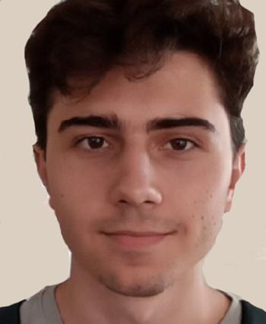

Name: Raúl Calero Capote

E-mail: [raucalcap@alum.us.es](mailto:raucalcap@alum.us.es)

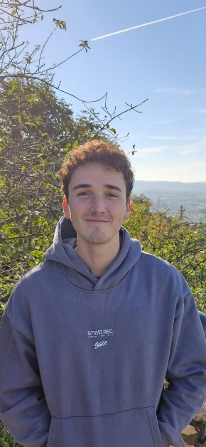Address: Avda San José de Calasanz nº9 7ºA, Dos Hermanas

Name: Miguel Prado Jiménez

E-mail: [migprajim@alum.us.es](mailto:migprajim@alum.us.es)

Address: Avda Eduardo Dato 44, Seville



Name: Tudor Cristian Lacatus Cosma

E-mail: [ionlac@alum.us.es](mailto:ionlac@alum.us.es)

Address: Avda Virgen de la Esperanza 16, 1 Derecha, Seville

# COMMITMENT STATEMENT

This statement confirms our group's commitment to working together to achieve our common goal. We also state that we have understood the syllabus of this subject, with particular attention to the evaluation system and grading procedures. As a team, we have agreed to commit to working toward an C grade. However, we agree on reviewing this goal once the current one has been met.

# PERFORMANCE INDICATORS

The following performance indicators will be used to determine the productivity and performance of team members, as well as their commitment to this project.

## Actual Grade vs Expected Grade

It is expected that in each follow up the group will compare the grade obtained, computed by looking at the fulfilled requirements and the expected grade. The difference between them will be computed and the results will be analyzed:

* If the difference is greater or equal than 0, the students are working properly
* If the difference is smaller than 0, the students are not working properly and hence will be admonished.

The good performance of a team member will consist on the following of all previously established indicators. A student will be classified as underperforming if some of the previously established criteria are not met.

# ACTIONS REGARDING PERFORMANCE

## Performing well

Members that surpass the expectations previously established will be performing well, and as such, they will get rewarded. This reward will consist on the ability to select their upcoming assigned tasks based on personal preference.

## Underperforming

Members that do not fulfill the previously established expectations will be underperforming, and as such, they will be admonished. This admonishment will consist of their future tasks being the ones left out by the other members.

## Dismissal conditions

After each follow-up, the performance of each member will be reviewed for that week. If a member is underperforming for 3 weeks without a valid reason (i.e. medical reasons), they will be immediately dismissed from the workgroup.

In case that a member is fired, they will be encouraged to work on their own, being able to access to all previous material elaborated before their expulsion.

# CONCLUSIONS

Summing up, this document assesses the commitment of all team members to the project, their shared goal and their contact information. It also highlights the recruitment process of all team members, and the expectations set for the measurement of their performance, as well as the consequences of their actions.

Signed,

Aarón Jesús Acuña Bellido – 18/02/25



Javier Arellano López – 18/02/25



Raúl Calero Capote – 18/02/25



Tudor Cristian Lacatus Cosma – 18/02/2025



Miguel Prado Jiménez – 18/02/2025

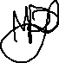

# BIBLIOGRAPHY

Intentionally blank